DOCK User Guide

Unprocessed Files
The unprocessed files screen can be accessed through the Search menu, option Amazon FC Unprocessed Files. The purpose of this screen is to give visibility over files that have not been uploaded into our system. This could be down to a timing issue and they are waiting for a job to kick in or because something went wrong and the file couldn’t be processed.

Last file received banner
The blue banner across the top of the page shows two types of timings. Firstly the last time the process ran, this date is updated every time the Parse XML file process runs from the scheduler as is simply to show that the job is running as expected.

The second line indicates when the last EDI file from Amazon was processed by our systems. As we get more files through the Amazon Paperless system, a recent timestamp here would indicate the AS2 communication with Amazon is functioning correctly for both Paperless and FC systems.

Unprocessed Files Channel
The unprocessed files channel is purely a view of our AS2 server, if you see a file in this segment it would indicate that we’ve received the file from Amazon but so far no Cole process has touched it.

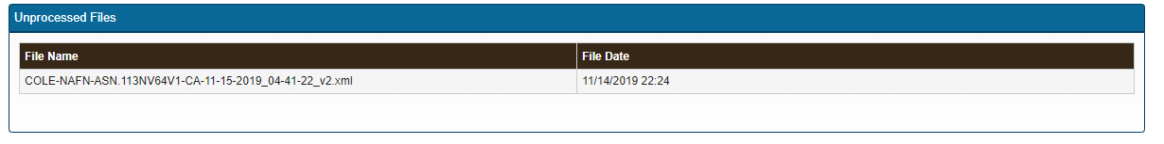

Seeing a file here is more than likely just a timing issue, our EDI job runs every 10 minutes so if the file date is very recent then there is no cause for alarm. However if the file date is older or it looks like there are several files over a period of time then it could be down to a system error and this should be investigated by IT.

Files Not Uploaded Channel
Any file shown in this channel has gone through the initial XML processing but as of yet hasn’t been uploaded to our CCI system. This could be for any of the reasons listed below.

Waiting to be processed
Once again most likely a timing issue, the initial XML parse and the secondary CCI data processing are two different process, if the stars align unfavorably it is possible that a file can take up to 30 minutes to become available for working on. So as with the first channel if the received date/time is fairly recent simply give it a little more time before assuming something is going wrong.

Duplicate
We sometimes get files sent through a second time and our programs are not setup to handle updates or alterations. As such any files that come through with a duplicate invoice number to something already in our system will be rejected and marked as a duplicate. Duplicates will vanish from this screen after 5 days.

If we know Amazon are sending over a revised version of a given invoice# and want it to be uploaded simply follow these steps:
- Wait for the revised invoice to show as a duplicate
- Ensure the original CCI hasn’t been imported into a transaction, if it has simply delete the applicable Across Invoice Header
- At this point the duplicate invoice will show the ‘Set to be Reprocessed’ button, click on this button to delete the original CCI and the system will then queue the revised file to be uploaded

Failed to process
Any file marked as failed is down to an actual error occurring, this could be a result of bad data within the file or a Cole program failing for some other reason.

If you see a file marked as such you can click the reprocess button and it will be placed back into a queue for reprocessing. If it failed purely because of a minor glitch then the file will go through as normal, if the issue is more data related then it will fail again. There is no harm in attempting to reprocess a file and more times than not it will most likely be fine the second time through. If you find that this is not working and the file always fails then it should be raised as a potential problem with IT.

Set to be reprocessed
Under the correct circumstances duplicates and failed files can be set to reprocess. What this means is the next time the EDI program runs it will see this file and attempt to upload it once again.

